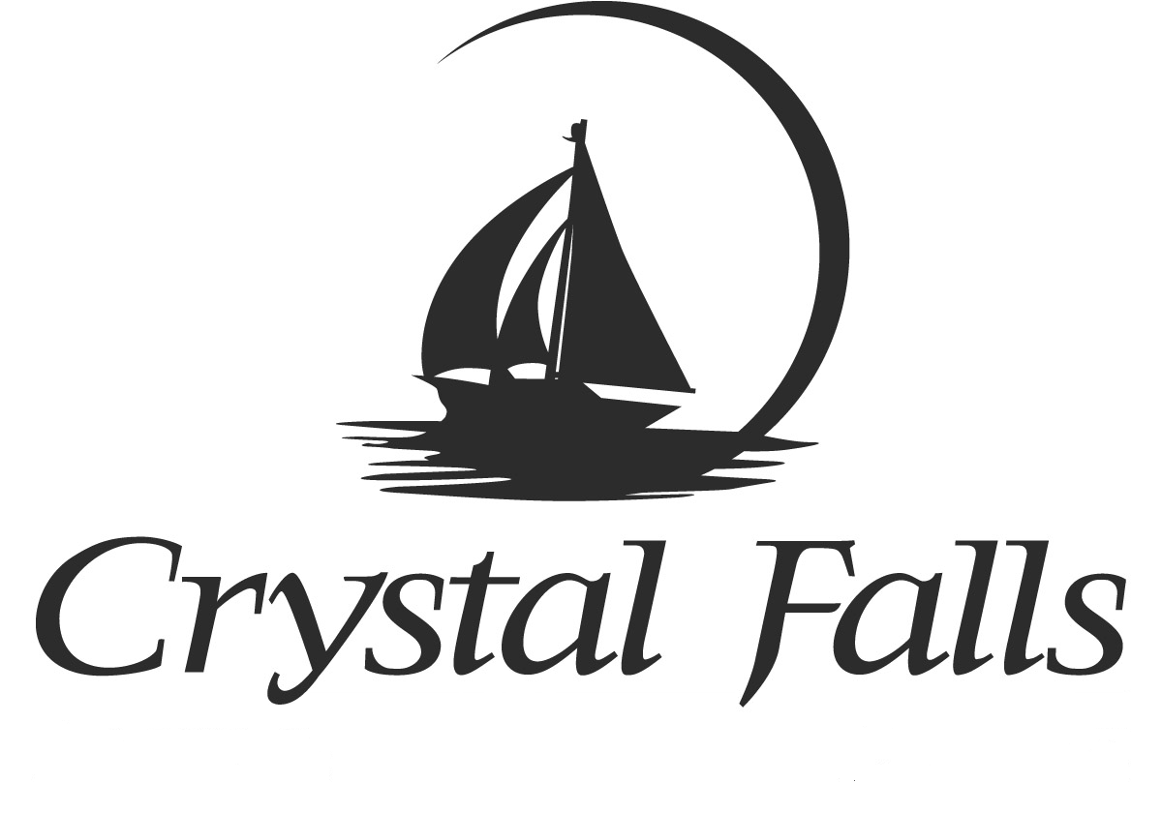
Crystal Falls Golf Club
Rates 2024

- Individual Memberships $345.00 Food & Beverage Minimum $35.00
Initiation Fee $5000.00

- Family Memberships $445.00 Food & Beverage Minimum $40.00
Initiation Fee $5000.00

- Corporate Membership $750.00
All must work for the same company
Must have 3 but no more than 5 Food & Beverage Minimum $35.00 Per Person
Initiation Fee $5000.00 Per Person

- Junior Membership $275.00 / (Ages 19-29) Food & Beverage Minimum $30.00
Initiation Fee $3000.00

- Weekday Individual Membership $250.00 / Tuesday thru Friday Food & Beverage Minimum $30.00
Initiation Fee $5000.00

- Weekday Family Membership $310.00 / Tuesday thru Friday Food & Beverage Minimum $30.00
Initiation Fee $5000.00

- Junior Membership $175.00 / (Ages 14 to 18)
Initiation Fee $1000.00

- Annual Cart and Dues $5700.00 (April thru March) (Individual)
Food & Beverage Minimum Not Included / Renewal Date 4/01/2023 / Non - Refundable

- Annual Cart and Dues $4560.00 (April thru March) (Individual Weekday)
Food & Beverage Minimum Not Included / Renewal Date 4/01/2023 / Non - Refundable

- Annual Cart and Dues $8340.00 (April thru March) (Family)
Food & Beverage Minimum Not Included / Renewal Date 4/01/2023 / Non - Refundable

- Annual Cart and Dues $6720.00 (April thru March) (Weekday Family)
Food & Beverage Minimum Not Included / Renewal Date 4/01/2023 / Non - Refundable

- All Memberships come with 4 free guest passes (cart fee not included)
Will be applied on member’s account April 1st, 2024

- Cart Fees $24.00 (18 Holes) / $12.00 (9 Holes)

